

S.B. JAIN INSTITUTE OF TECHNOLOGY MANAGEMENT & RESEARCH, NAGPUR

Practical 02

Aim: To understand and demonstrate the use of basic commands in different operating systems (Windows, Linux, and UNIX) for managing files, directories, permissions, and user interactions through a terminal or command-line interface.
Name: Piyush Thorve
USN:CM25D005
Semester / Year: Academic Session: Date of Performance: Date of Submission:
- Aim: To understand and demonstrate the use of basic commands in different operating systems (Windows, Linux, and UNIX) for managing files, directories, permissions, and user interactions through a terminal or command-line interface.

Objectives:

  - To learn and practice fundamental command-line operations for file and directory management.
  - To explore and utilize user and permission management commands effectively.
  - To enhance system administration skills by working with commands across different operating systems.

Requirements:
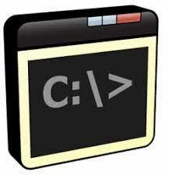
Hardware Requirements:

  - Processor: Multi-core CPU, Intel Core i3 (3.0 GHz) or higher
  - RAM: Minimum 4 GB (8 GB recommended for optimal performance)
  - Storage: 100 GB HDD or SSD (Solid State Drive) for faster access
  - Network Interface: Ethernet or Wi-Fi adapter for connectivity

Software Requirements:

  - Operating System: Windows 10/11, Linux (Ubuntu 20.04/CentOS 8), UNIX-based OS
  - Command-line Interface: PowerShell or Command Prompt (Windows), Terminal (Linux/UNIX)
  - Text Editor: Nano, Vim, or Visual Studio Code for file editing
  - Administrative Privileges: Superuser (Linux/UNIX) or Administrator (Windows) access

Theory:
In system administration, command-line interfaces (CLI) are essential tools for managing and interacting with operating systems like Windows, Linux, and UNIX. Commands allow users to perform various tasks such as navigating directories, managing files, controlling permissions, and monitoring system performance. Each operating system provides a set of built-in commands, such as ‘man’, ‘ls’, ‘cd’, ‘mkdir’, and ‘chmod’, to facilitate efficient system management. Understanding these commands and their syntax is crucial for automating tasks, enhancing security, and ensuring optimal system functionality. This practical aims to develop foundational skills in executing and applying basic commands across different platforms.

Commands:
- Display User Manual of a Command
  - Functionality: Shows the manual page with details about a command’s usage, options, and arguments.
  - Syntax: man <command>
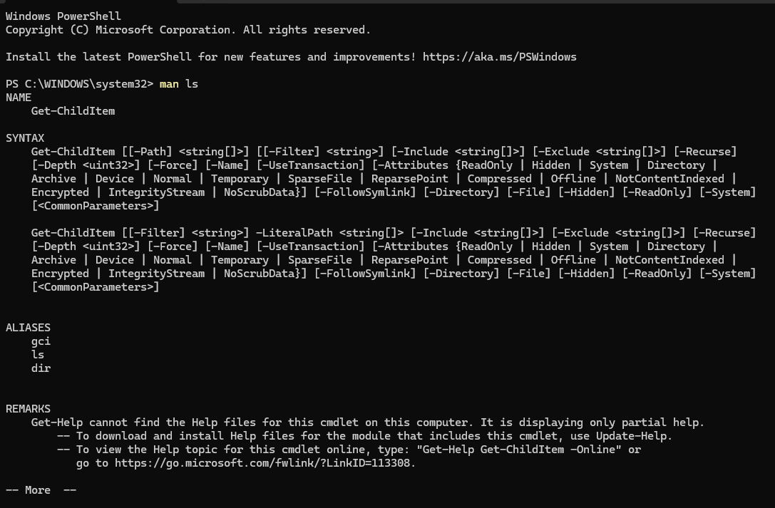
  - Example: man ls

Change Current Working Directory.
  - Functionality: Changes the terminal’s current working directory.
  - Syntax: cd <directory-path>
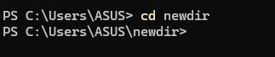
  - Example: cd /home/user/Documents.

List Contents of the Current Directory.
  - Functionality: Lists all files and directories in the current location.
  - Syntax: ls
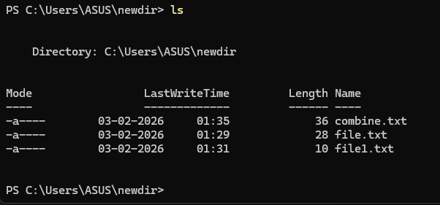
  - Example: ls

Read/Modify/Concatenate Text Files.
  - Functionality: Displays or manipulates file content.
  - Syntax:
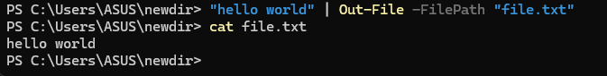
    - Read: cat <filename>
    - Modify: ‘nano <filename>
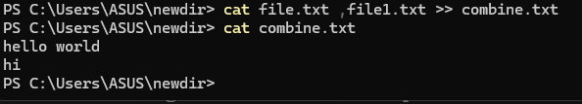
    - Concatenate: cat <file1> <file2> > <outputfile>

Create a New Directory.
  - Functionality: Creates a new directory at the specified path.
  - Syntax: mkdir <directory-name
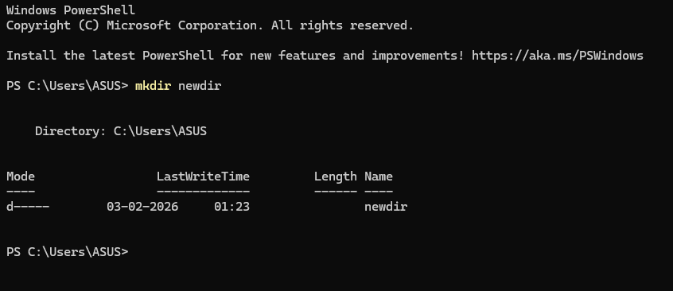
  - Example: mkdir newdir

Display Current Working Directory.
  - Functionality: Prints the current directory path.
  - Syntax: pwd
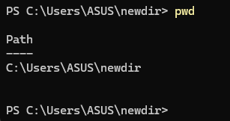
  - Example: pwd

Write Arguments to Standard Output.
  - Functionality: Prints the provided string or variables.
  - Syntax: echo <arguments>
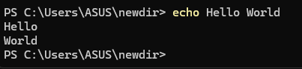
  - Example: echo Hello World

Remove a File.
  - Functionality: Deletes a specified file.
  - Syntax: rm <filename>
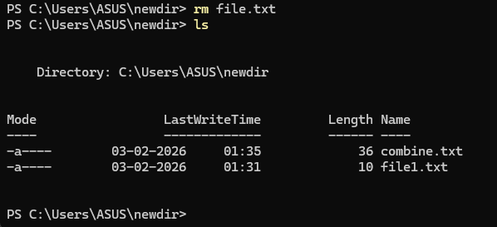
  - Example: rm file.txt

Delete a Directory.
  - Functionality: Removes an empty directory.
  - Syntax: rmdir <directory-name>
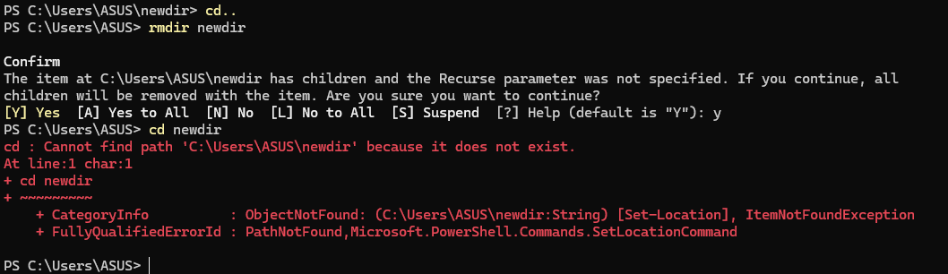
  - Example: rmdir olddir

Copy a File or Directory.
  - Functionality: Copies a file or directory to a destination.
  - Syntax: cp <source> <destination>
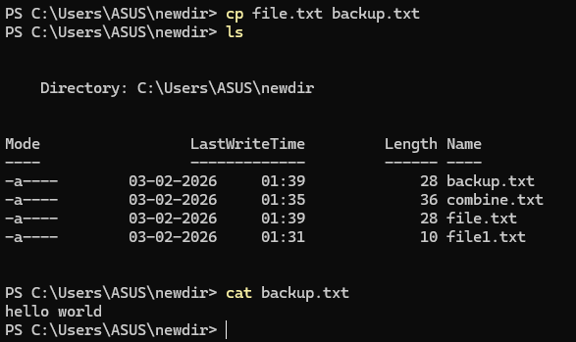
  - Example: cp file.txt backup/

Switch to Root User.
  - Functionality: Gains root privileges temporarily.
  - Syntax: sudo su
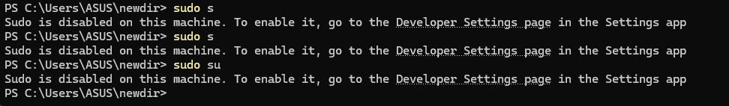
  - Example: sudo s

Move Files or Directories.
  - Functionality: Moves or renames files and directories.
-Syntax: mv <source> <destination>
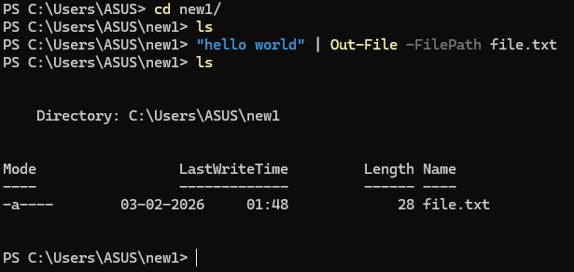
  - Example: mv file.txt newdir/
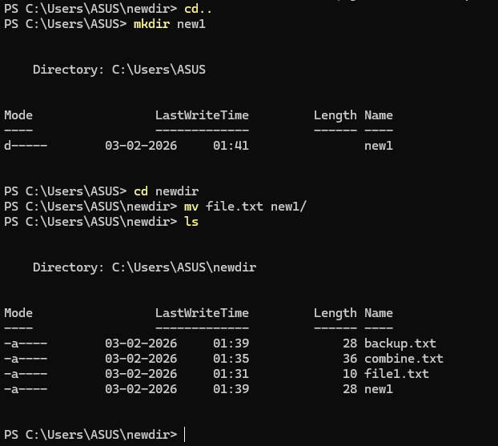

Search for a String in a File.
  - Functionality: Searches for a specific word or pattern in a file.
  - Syntax: grep "<string>" <file>
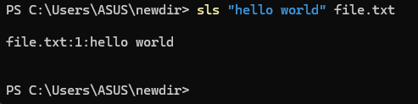
  - Example: grep "error" log.txt

Print Top N Lines of a File.
  - Functionality: Displays the first N lines of a file.
  - Syntax: head -n <N> <file>
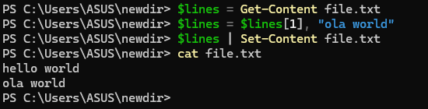
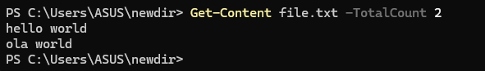
  - Example: ‘head -n 10 file.txt’

Print Last N Lines of a File.
  - Functionality: Displays the last N lines of a file.
  - Syntax: tail -n <N> <file>
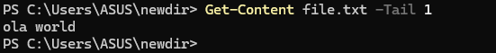
  - Example: ‘tail -n 10 file.txt

Remove Read Permission from Owner.
  - Functionality: Revokes the owner’s read permission for a file.
  - Syntax: chmod u-r <filename>
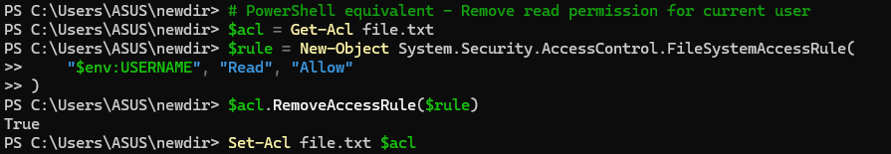
  - Example: chmod u-r file.txt

Change Specific Permissions.
  - Functionality: Sets or removes specific file permissions.
-Syntax: chmod u+r,w-x,g+w <filename>
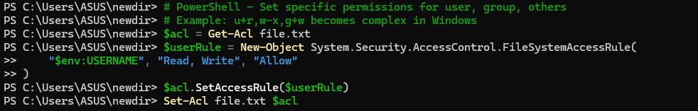
  - Example: chmod u+r,w-x,g+w file.txt

Add Write Permission to Owner, None to Others.
-Functionality: Allows write access for the owner only.
  - Syntax: chmod u+w,o-rwx <filename>
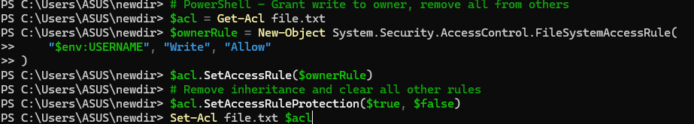
  - Example: chmod u+w,o-rwx file.txt

Assign Permissions to Users.
  - Functionality: Modifies file access for users, groups, and others.
  - Syntax: chmod u+rwx,g+rx,o+r <filename>
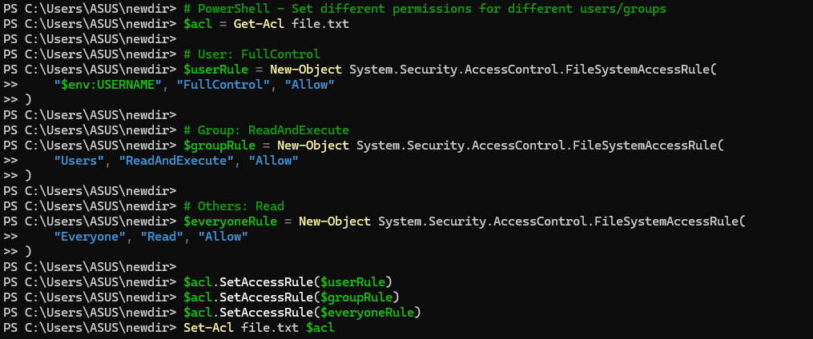
  - Example: ‘chmod u+rwx,g+rx,o+r file.txt

Assign R/W/X to Others.
  - Functionality: Gives read, write, and execute permissions to others.
  - Syntax: chmod o+rwx <filename>
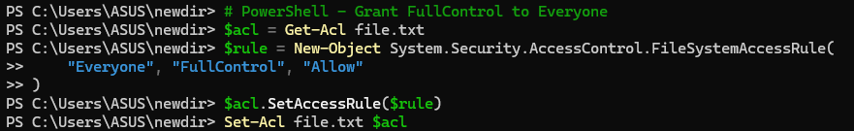
  - Example: chmod o+rwx file.txt

Remove All Permissions from All Users.
  - Functionality: Clears all permissions on a file.
  - Syntax: ‘chmod a-rwx <filename>
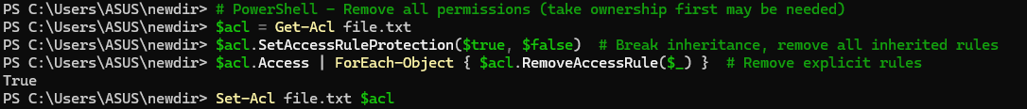
  - Example: ‘chmod a-rwx file.txt

Remove Read Permission Using Absolute Mode.
  - Functionality: Uses numeric mode to restrict read access.
  - Syntax: chmod 700 <filename>
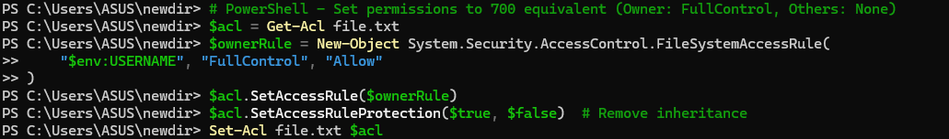
  - Example: chmod 700 file.txt

Set R/W for Owner, None for Group/Other.
  - Functionality: Assigns permissions in numeric mode.
  - Syntax: chmod 600 <filename>
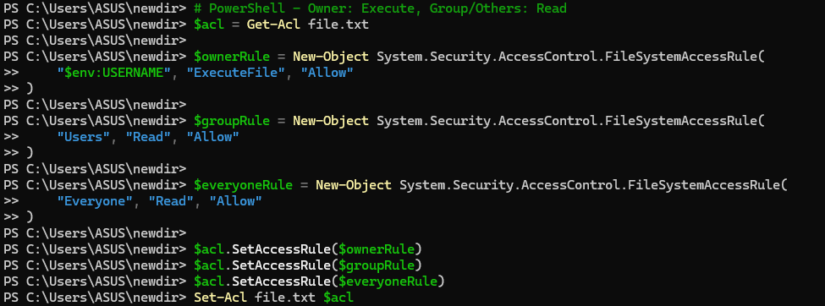
  - Example: chmod 600 file.txt’

Add Execute for Owner, Read for Group/Others.
  - Functionality: Adds execution and read access.
  - Syntax: chmod u+x,g+r,o+r <filename>

  - Example: chmod u+x,g+r,o+r file.txt

Add Execute Permission to All Users.
  - Functionality: Enables execution by everyone.
  - Syntax: chmod a+x <filename>
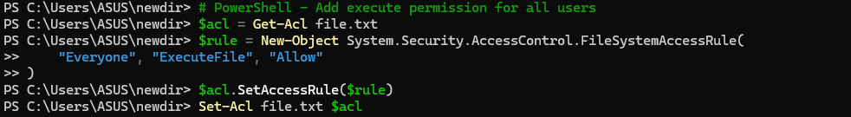
  - Example: chmod a+x script.sh

- Conclusion: In conclusion, understanding and using essential operating system commands like ‘ls’, ‘cd’, ‘cp’, ‘mv’, and ‘chmod’ enables efficient file management, navigation, and permission control. Tools like ‘grep’, ‘head’, and ‘tail’ enhance data processing. Mastery of these commands improves system administration, task automation, and overall system security and performance.

Discussion Questions:
  - What is the significance of the pwd command in a Linux environment?

Explain the function of the cp command and its common options.

How does chmod 700 affect file permissions, and what does each digit represent?
  - Describe the difference between head and tail commands in Linux.

What is the purpose of the grep command, and how is it used with regular expressions?

References:
https://ubuntu.com/tutorials/command-line-for-beginners#1-overview https://www.geeksforgeeks.org/25-basic-ubuntu-commands/

Date: / /2026 Signature
Course Coordinator B.Tech CSE(AIML) Sem: 4 / 2025-26

